Project Narrative
Dodrill ADU application

The proposal is to convert to an ADU part of an existing structure built for a 501(c)(3) public charity (Pipe Organ Foundation). The space was specifically built for volunteers to do the work of the Foundation, and people met in the room for meetings, meals, and bench work. To accommodate these people, the original structural design included a 1/2 bath, hot and cold water, a 10-foot countertop, and fire protection separations from the adjoining garage. The primary work of the charity was done in this space with the result that many pipe organs were saved, rebuilt and located in public settings at low cost (the largest of these was placed in Mercer Island Presbyterian Church). Due to the limited space and due to the space needs of the Foundation, a shower was not originally installed. Nevertheless, when a project did not fill the space, it was always available for overnight use and volunteers as far away as Alaska could use it when they had no other place to stay.

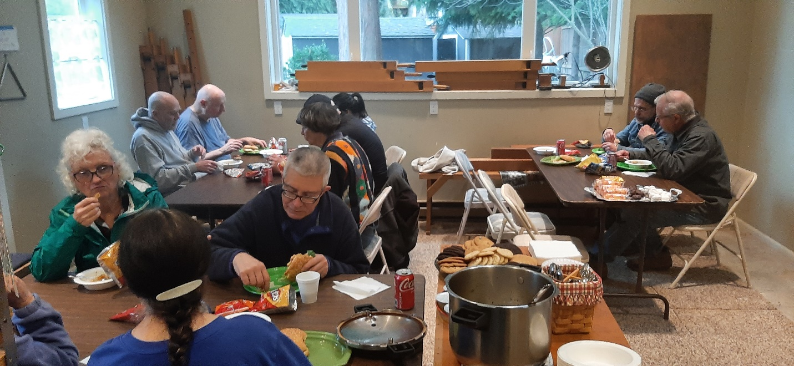

A great deal of work is involved in the rebuilding of a pipe organ, but using volunteers saves huge amounts of money as there are no salaries, even for the President. Most people are in fact able to learn basic organ rebuilding skills if given close direction.

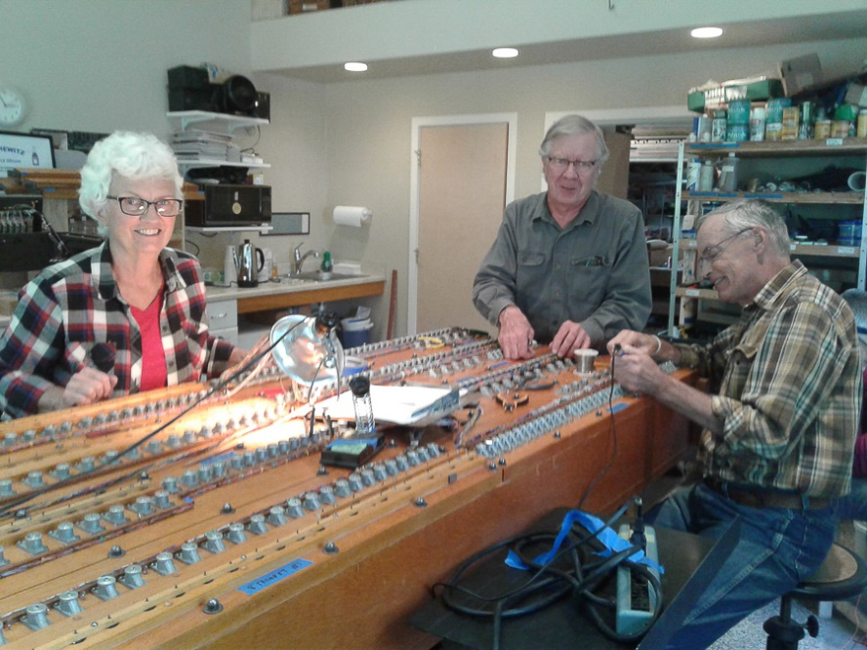

As the space to be used for an ADU was designed for people and has always been used by them, only a few changes are needed. The 1/2 bath is to be expanded to a 3/4 bath with the addition of a shower to be located where the current kitchen sink is situated. The long countertop will be modified and moved north, and an electric stove top and a smaller sink will be installed in that countertop. Limited changes will be required in the walls including moving the short wall of the bathroom north 3 ½ feet, building a wall around the closet area, putting a wall in place of the fire door to the garage, and building a pony wall to partially separate the sleeping space from the main living space. Electrical, plumbing, and constructional work will be needed to accommodate these changes. This is the scope of the entire project.
There are no changes to the building footprint, there are no changes to the site, and ample parking is readily available. In terms of fire protection, it is noted that fire flow appears to be strong, that a fire hydrant is close at hand, and that the access road is wide, straight, and level. In addition, it is noted that a special smoke detection system is already in place by which an alarm goes off inside the detached house should the smoke detector ever go off in the ADU space.
Please refer to the architectural plans attached which give critical information about the site and about the interior non-structural alterations which are being proposed. The two photos below also give an overview of the project.
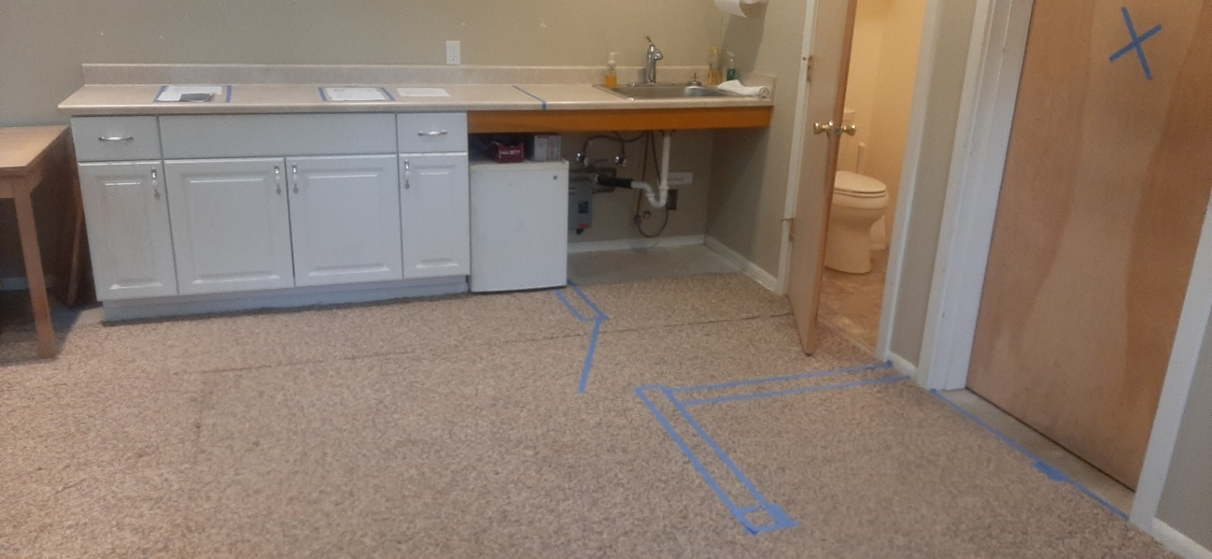
A solid wall will be put in the place of the door on the right. The open door to the bathroom shows the stool and there is also a sink in the bathroom which will remain. The short wall on which the open door is hinged will be removed. The shower will be located where the stainless-steel sink is currently situated. The countertop will be moved to the left and fitted with a two-burner electric stove and a small sink.
The blue tape on the floor shows where the walls will be constructed. The blue tape going under the small existing refrigerator shows the wall that will be just north of the shower, and the 30-inch door which will hinge outward is shown. The continuation of that wall will be on the north side of the closet, the back of which is the wall between the closet and the bathroom. Finally, a small pony wall just inside the entrance door will provide some division between the bedroom area and the general living space.
